HCAD HOUSEBILL

The HCAD House Bill Documents contains the following information
- Appraisal Evidence Summary
- Property Description
- Equity Analysis
- Neighborhood details (Comparable Sales)
- Maps/Photos
Housebill process could be help for file prep team to prep the accounts with all comparable sales information which will be presented by the hearing agents while attend hearings.
HCAD Housebills – We will download HCAD Housebills from HCAD agent website.
HCAD House bills processed for only hearing scheduled accounts in spartaxx.
HCAD House Bills will be downloaded in two categories.
- Manual Download
- Nightcrawler Application.
Manual Downloads: -
Use HCAD.org to pull the agent login page.
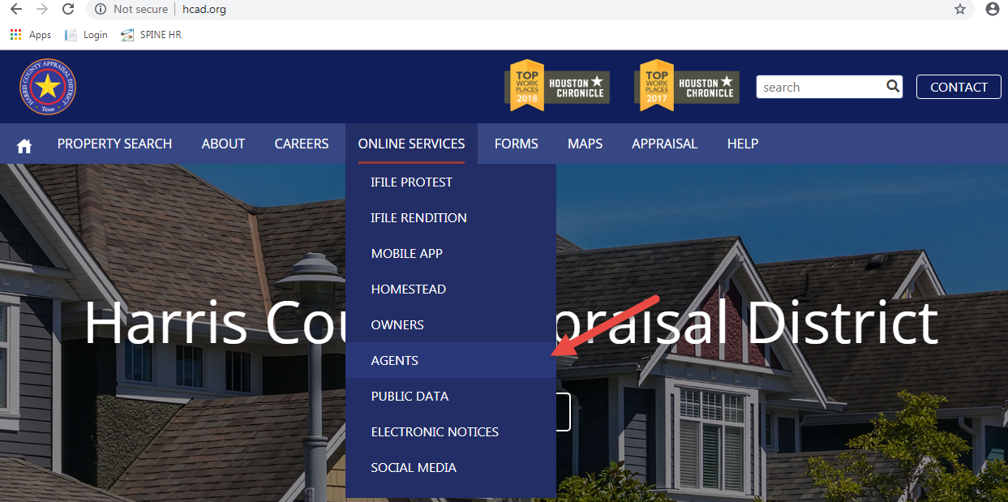
Agent Login details:-
- User Name – 00463
- Password – proptax12@@
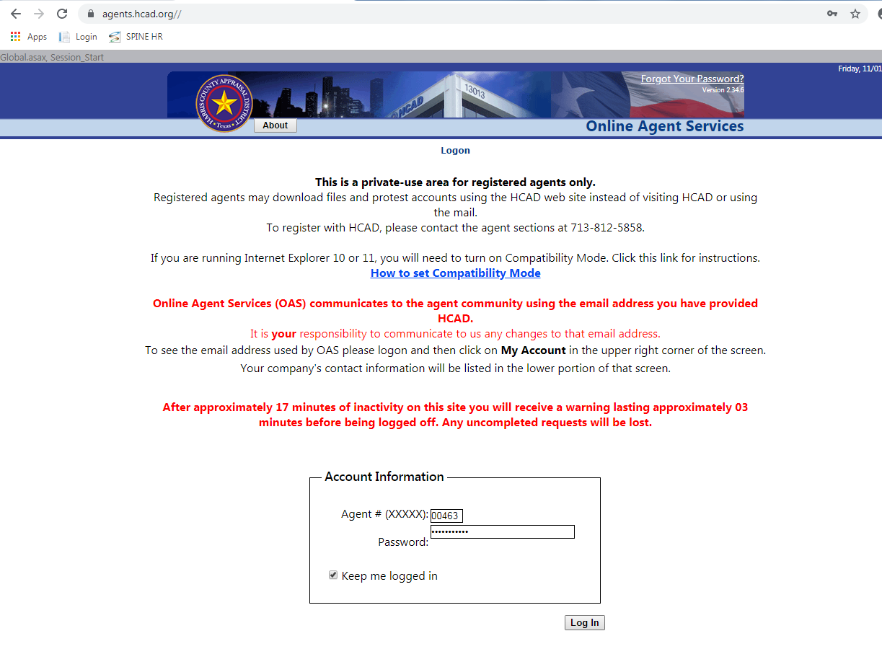
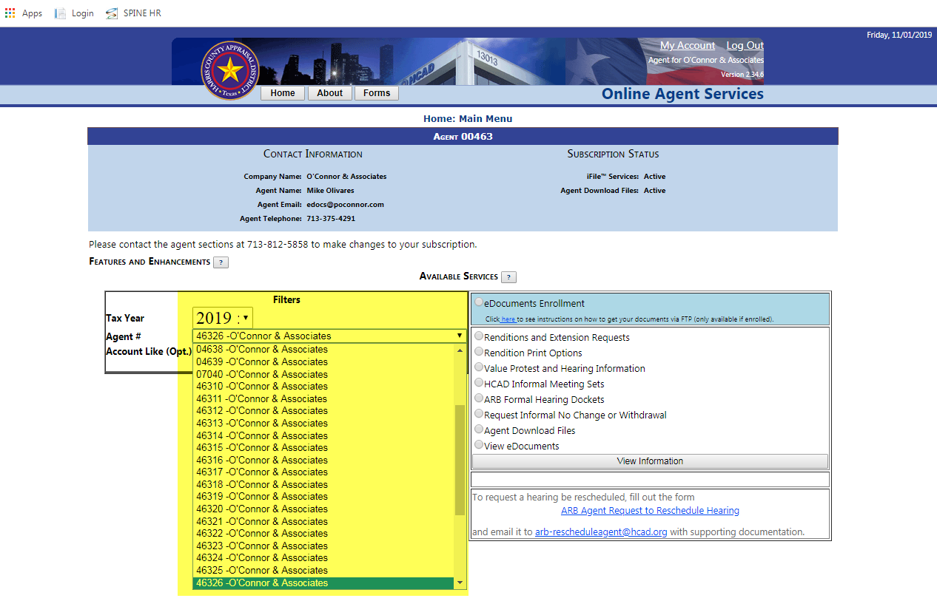
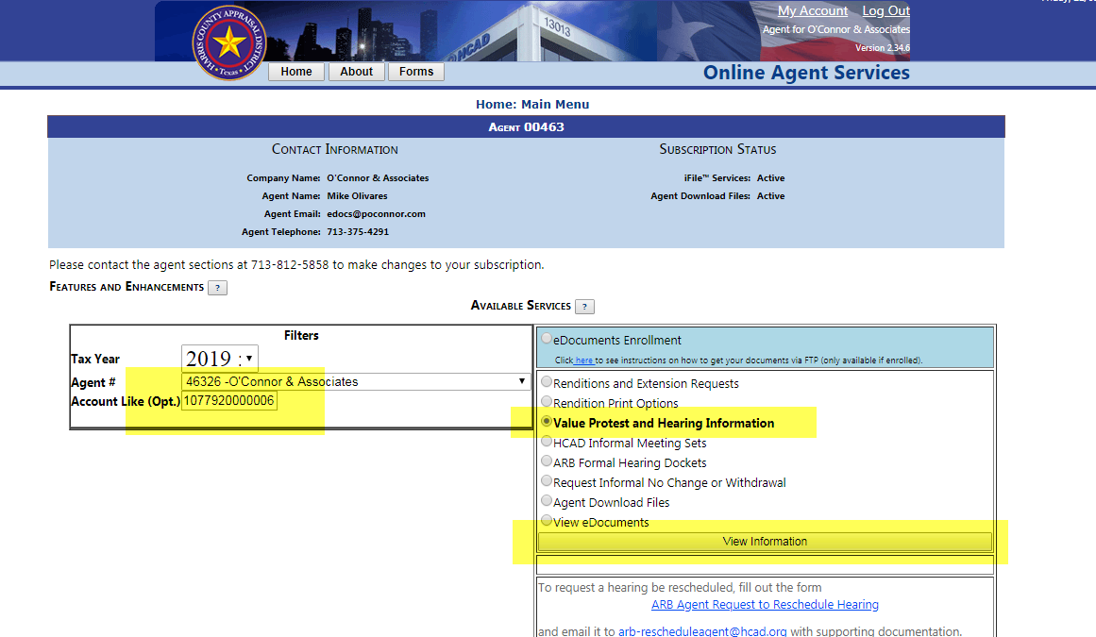
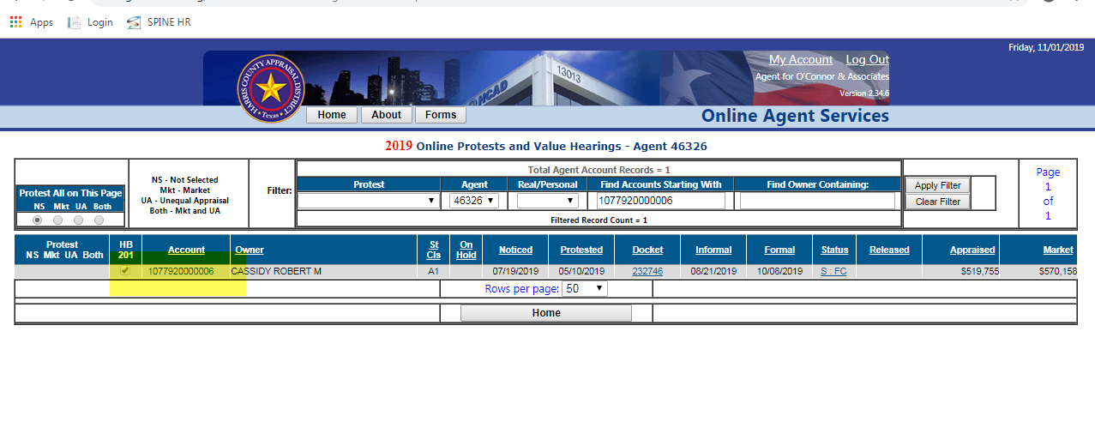

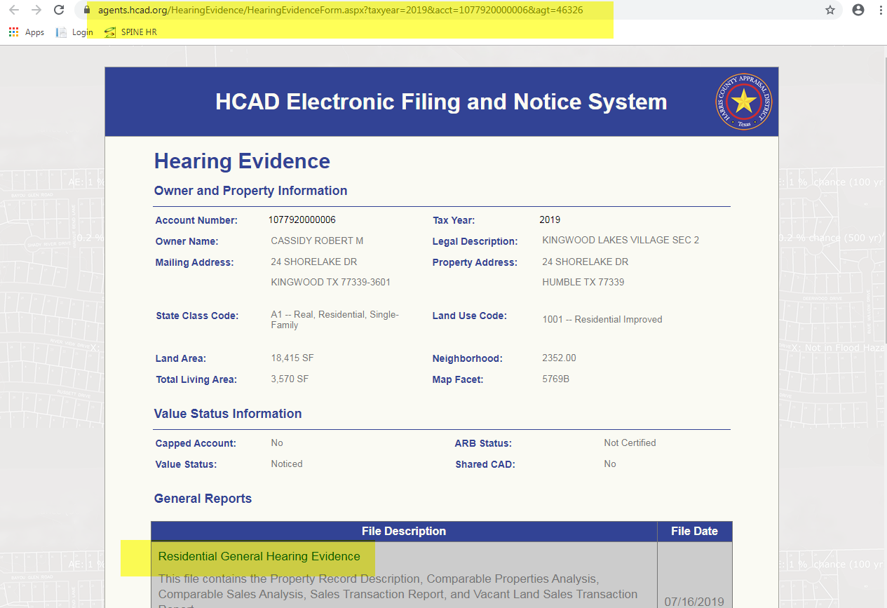
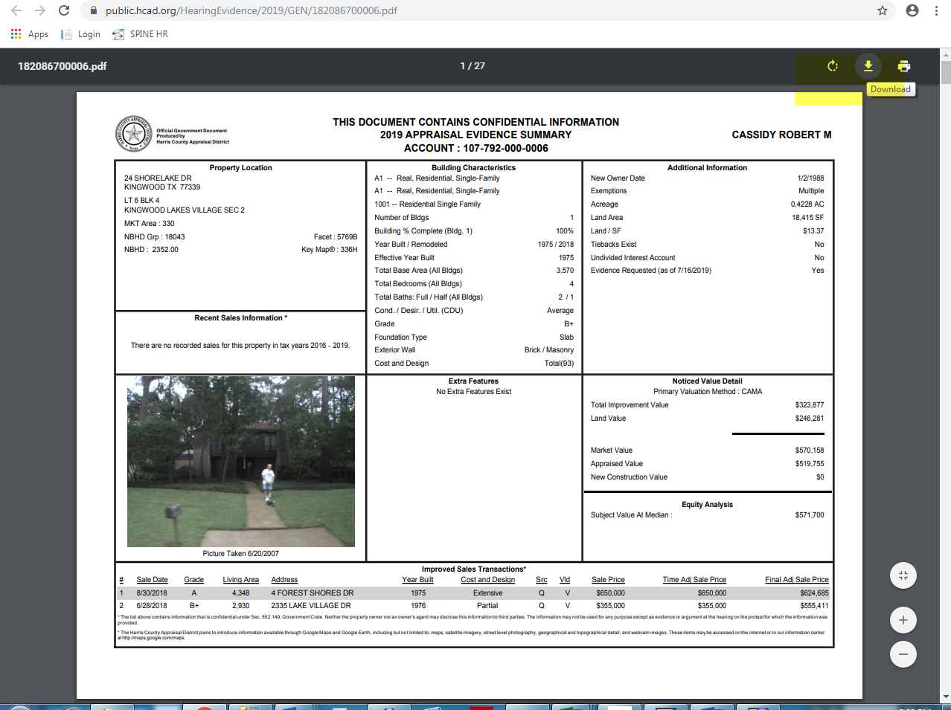
Downloaded documents will be uploaded into paperwise by using sendto option in paperwise.
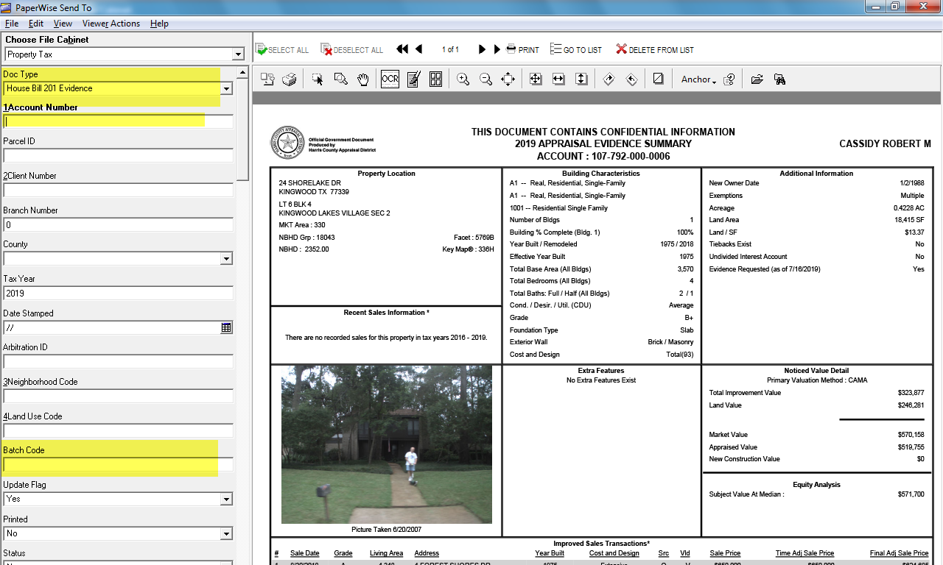

Nightcrawler Downloads:-
- We run the SQL Query daily to find hearing schedule accounts for running nightcrawler application from Spartaxx.
- We will get the account number list for all who are active in the spartaxx account on the mentioned date. In which, we should run nightcrawler only for OCA agent ID coded accounts.
- Fiduciary Information details will be present in respective HCAD account page as given below in the screen shot.
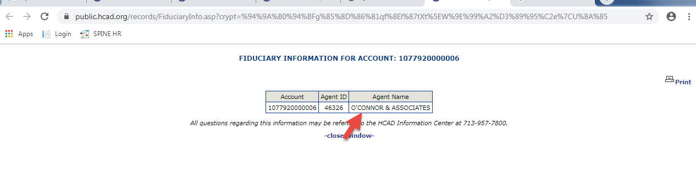
Nightcrawler application will download the HCAD Housebill automatically from HCAD agent website and upload the document into paperwise.
Once after taken OCA agent accounts, we should prepare the spreadsheet with the below headers
Account number, Agent id, Tax year and scan date will be mapped manually .
Opening Nightcrawler application:-
Browse the prepared excel sheet and upload into Nightcrawler application by using upload option.
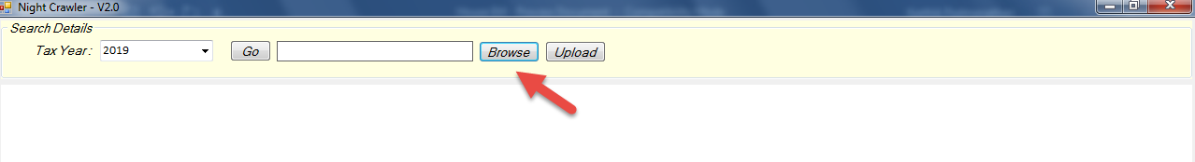
After successful runs nightcrawler will pop the message like “No.of Housebills uploaded successfully”.
Those housebills were automatically uploaded to paperwise for sales processing.

HB Extractor:-
- HB Extractor and paperwise have linked in database.
- The HB scanned on the date will be scrapped by HB Extractor tool.
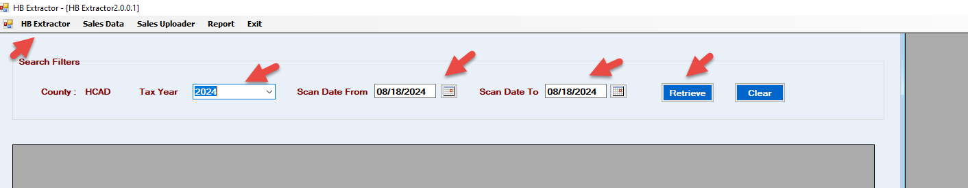

We have the option to retrieves the data from Paperwise and those sales need to extracted by using Extract Sales button.
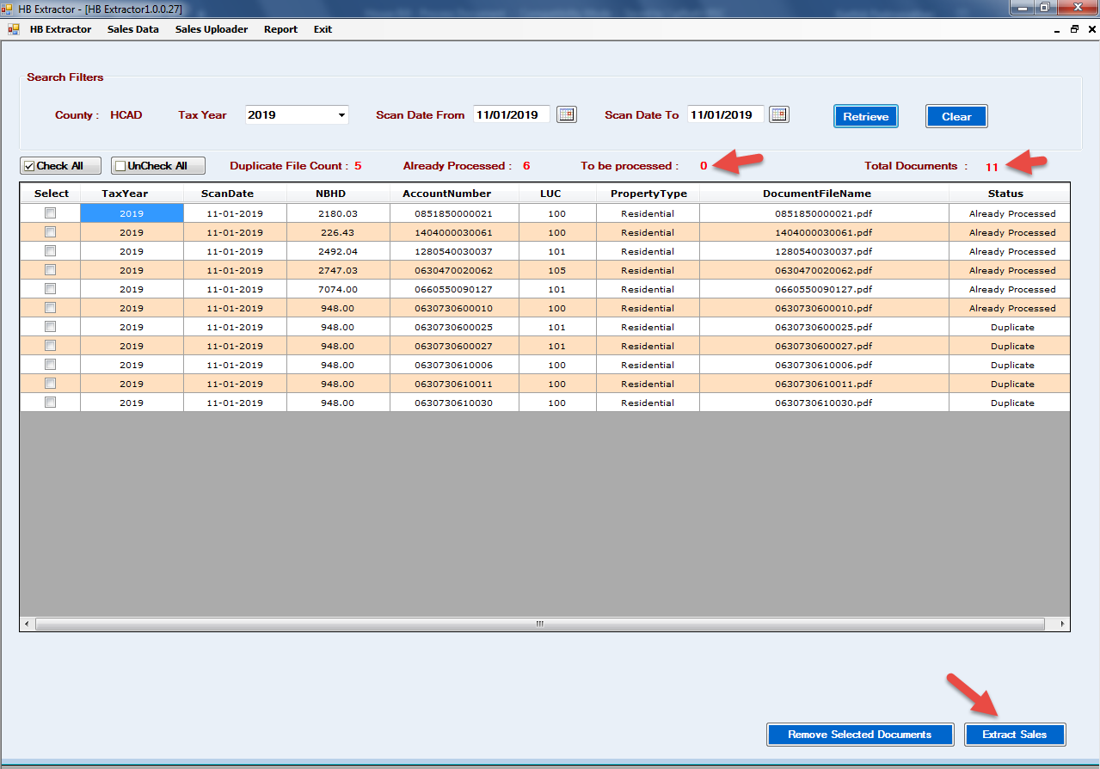
Batch Creation:-
Extracted sales information will be scrapped as Batches in sales Data link in HB Extractor. Users should find the scrapped sales from recently created batch ID.
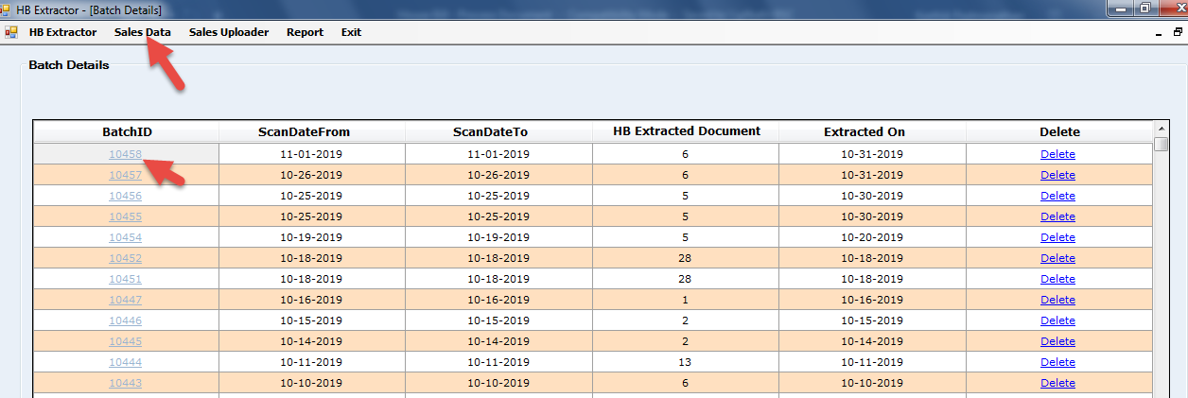
Extractor will show the scrapped log in to separate files as below.
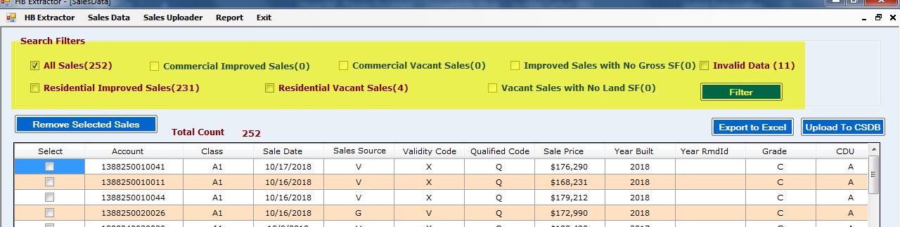
Users will have filter option for each category and export the sales in Excel from “Export to Excel” Option.

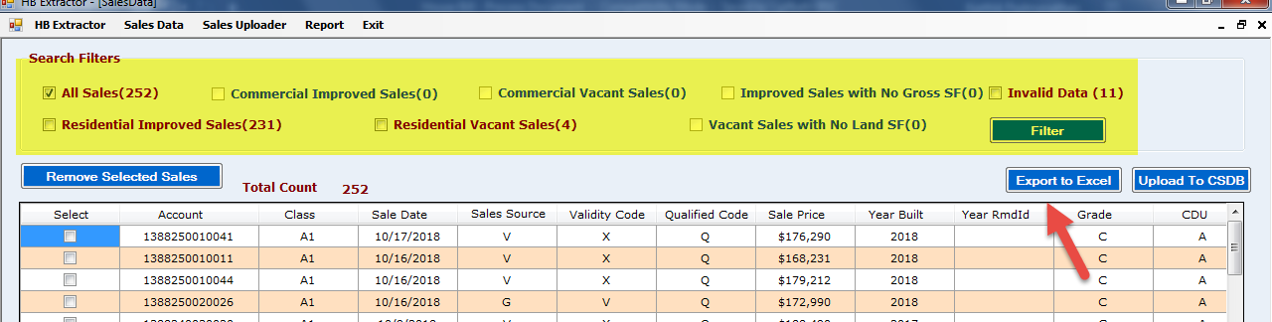
Sales PDF:-
- All the separated sales saved in the pdf format in the user C drive.
- By Neighborhood, for Neighborhood, IST.
- All the exported sales excel will be stored in the user system and user can cross validate the excel data with the extracted pdfs which is saved in the C drive in the user machine.
HB Sales Uploading template:
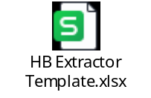
Sales Uploader:-
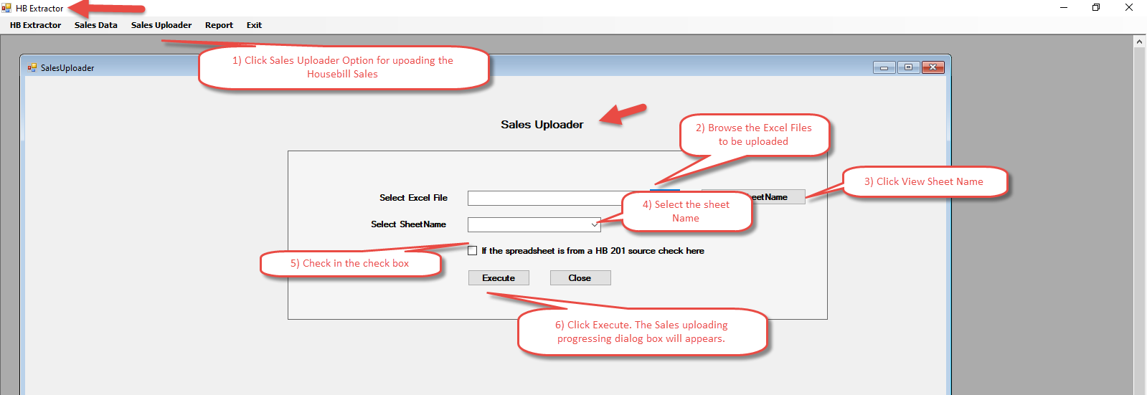
Finally, the sales will be moved into the sales database.

